
34, VISHALA ESTATE, S.P.RING ROAD,OPP.ODHAV TO NIKOL ROAD, NIKOL, Ahmedabad, Gujarat, 382350
GST NO:-:24ARDPD2565K1ZX

info@torqpackagingsolution.com
www.torqpackagingsolution.com

Date: - 24/12/2022

To.
Mr. Rakesh Reddy
M/s VNR Global
Manikonda, Hyderabad.

Sub: - AUTOMATIC MILK POUCH PACKING MACHINE

Dear Sir,
Many thanks for your valuable inquiry of above subject. TORQ PACKAGING Solutions Is engage in making preliminary Bottle Packaging machines like bottle filling , capping , labeling, Automation, etc… in Ahmedabad, We are having dedicated team for manufacturing, customized machine development, Sales, servicing and back office.

Thanks & Regards
Ronak Dave
+91 80000 32128

Sr.No | Description | Qty | Unit Rate (Rs.)
1 | Model : TPS-PP-O3 (250 to 1000 ml)  Scope of Supply along with Machine:  - Photo Mark Sensor with fittings  b) Positive displacement Pump with Motor | 1 | 2,80,000/-

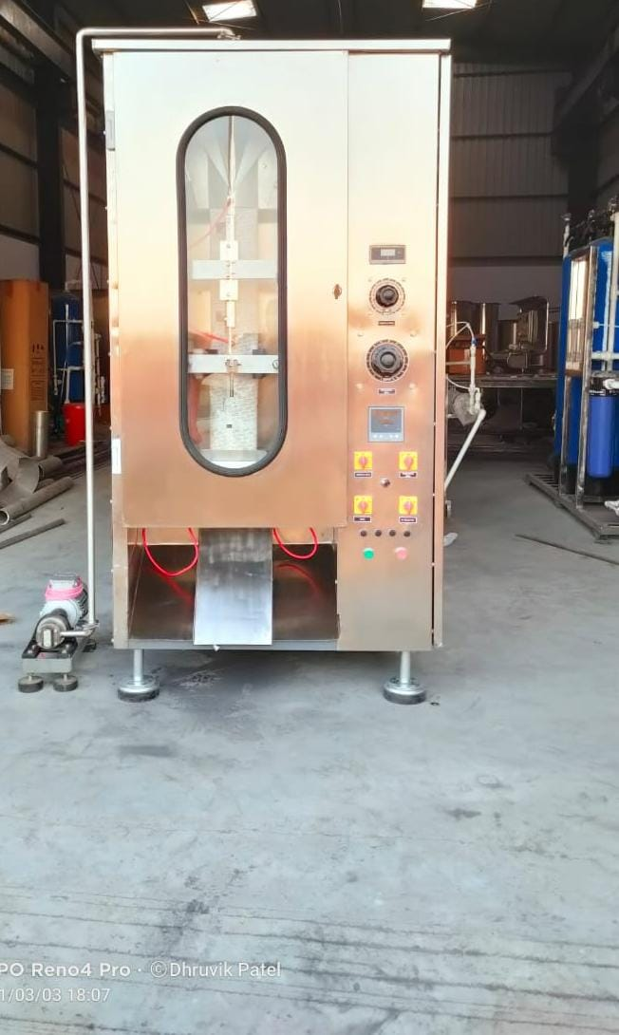

S.No | Specifications
1 | Product to Pack | Edible Oil / Ghee /Milk (Any High Viscous Products)
2 | Type of Machine | Fully Automatic Normal Speed Single Head Mechanically controlled through PLC/ CONTROLLER
3 | Model | TPS-PP-03
4 | Feeding systems | Volumetric Filler
5 | Packaging range | 200/250/500/1000 ml
6 | Accuracy in volume | +/- 0.5% of the Quantity Packed
7 | Accuracy in length | +/- 2mm
8 | Speed of the machine | 20 TO 22 Pouches/Min
9 | Packing Material | LD / Bonding/Nylon Bonding/ Prime core
10 | Film thickness | 75 to 110 microns
11 | Film width | 325+/-2mm
12 | Film roll weight | 15 to 20 kgs
13 | Type of seal | 3SIDE SEAL / CENTER SEAL Y--Impulse heat seal
14 | Material of construction | S.S-304 / M.S / Aluminum
15 | Gear Pump/ FILLING CONTECT PARTS | S.S 316
16 | Movement / operation | Eccentric Cam operated
17 | Product Feed System | Positive displacement Pump with Motor
18 | Electric and Instrumentation | - PLC –HMI /Control  - VFD  - Step Down Transformer AC
19 | Cooling water requirement | ---
20 | Power Consumption | 5 K.W / Hour (Single phase)
21 | Machine weight | 450 kgs Approx.
22 | Photo sensor | Included
23 | Date Coding unit | Client Scope .
24 | Pouch counter | Built in PLC
25 | Safety Parameters | - The entire electrical component with proper earthling and cover.  - Emergency stop switch when incoming supply cutoff  - Manual emergency stop  - Film roll end  - Film roll unwinding  - During power failure the machine shall stop / normal position.
26 | Maintenances and Operational Requirements | - 3 phase / Single Phase electrical power (415V, 50Hz) (to be provided by Client)
27 | Site Installation and Field Identification | - Earthling to Machine (Before Commissioning)  - Machine shall be installed in slope (as per the Manufacturer rep)  - No water spillage over and above the machine  - Only manual cleaning , No spray or Jet washing
28 | Warranty certificate | - Warranty certificate for the equipment for the period of 12 months from the date of dispatch against any manufacturing defects

Price Breakup
S.N. | PARTICULERS | CAPACITY | QTY | AMOUNT USD
1 | AUTOMATIC MILK POUCH PACKING MACHINE WITH CHILLER | 250 TO 1000 ML | 1 | 2,80,000/-
 | BANK DETAIL :  Account name :- TORQ PACKAGING SOLUTION  Account number :- 8000032128  Bank name :- KOTAK MAHINDRA BANK LTD  Branch :- KATHWADA  IFSC :- KKBK0002606  COMPANY GSTIN : 24ARDPD2565K1ZX | TOTAL |  | 2,80,000/-
 |  | CGST @ 9%
 |  | SGST @ 9%
 |  | IGST @ 18% |  | 50,400/-
TOTAL AMOUNT |  |  |  | 3,30,400/-
TERMS & CONDITIONS |  | For, TORQ Packaging Solution
- 50 % Advance on Signing up of Contract
- 50% On Completion of Machinery Manufacturing Before Dispatch / During Inspection of machinery
- Order Once Placed Cannot be Cancelled
- No Refund will be entertained

- Terms & Conditions

1 | PRICE | The prices mentioned are ex our Ahmadabad works
2 | TAXES & DUTIES | 18% extra
3 | TERMS OF PAYMENT | We agreed to have 50% advance and 50 % before Dispatch.
4 | DELIVERY  PERIOD | Within 3-4 Weeks from the date of receipt of technically & commercially clear order along with advance payment or receipt of approval for input dimensions, whichever is later
5 | INSURANCE | Transit Insurance against Theft, Pilferage, Breakage, Etc. will be arranged at extra cost at your explicit instruction, otherwise it will be assumed that goods are to be sent at your risk. Cost of such insurance will be as actual to be borne by the consignee.
6 | TRANSPORT | Transportation of the machine from our factory has to be arranged by you. We will arrange for loading of the equipment at our factory. However unloading at site has to be arranged by you. Our responsibility ceases once the goods leave our factory and are handed over to carrier. We do not undertake any liability for damage/ loss in transit whatsoever, whether the goods are insured or not. In case of any damage / accident during transit, the client has to directly deal with the insurance company without holding any payments, irrespective of the insurance arranged by Consigner or Consignee.
7 | INSPECTION | We offer inspection of the machine at our factory, by your technically competent representative, prior to dispatch. This person should be present on our factory during packing and loading of the machine. In case you are not deputing anyone for pre dispatch inspection, then we will not entertain any dispute arising out of short supply, quality, workmanship, functionality, operating parameter, etc. once the machine is dispatched.
8 | FACTORY  TRAINING | We will impart training to your operating staff in our factory before the machine is dispatched, at no additional cost. However, his lodging-boarding and local traveling expenses will have to be borne by you. This person should be technically competent to uncrate and assemble the machine at site before the arrival of our commissioning engineers. He must ensure that ground work necessary at site is competed in all respects before machine. Commissioning, He must be competent enough to be able to run the machine and carry out routine maintenance, once the machine is handed over after commissioning
9 | INSTALLATION | The machine has to be uncarted and placed in working position by you at site. You have to carry out all the external powers and air compressor at site. The machine must be available in the fully assembled condition when our commissioning engineer arrives at site.
10 | COMMISSIONING | For supervising and commissioning of the machine we will depute one of our engineers on chargeable bases. Customer will have to send a prior intimation of readiness of electrical and utility connections along with required materials.  Rs. 2,000/- per man day will be charged. Customer will reimburse to and for 1st class fare from  Ahmedabad to the destination, lodging and boarding expenses and other local expenses for the period of commissioning.
11 | SPECIFICATION | In line with our policy of continual improvements, we reserve The right to modify the design and change the specifications and make of any material, if in our opinion such modification leads to an improvement in the performance of the machine. Therefore specification, illustrations, dimensions, offers, drawings or photographs are not binding in detail.
12 | WARRANTY | Our goods carry a warranty of one-year trouble free operation from the date of dispatch. The warranty is only against manufacturing defect. It does not cover any electrical, electronic or bought out components.  Components getting normal wear and tear would be replaced at your cost.
13 | NOTE | Customer have to provide samples of bottles, caps, labels etc. along with the purchase order otherwise machine will be made as per our standard specifications, wherein we will take trial with water, caps, bottle, label etc available with us, which will be acceptable to you.
14 | CANCELLATON  OF ORDER | Order once placed, cannot be cancelled under any circumstances. In case of orders being cancelled, then the entire amount of advance payment will stand forfeited.
15 | OFFER VALIDITY | This offer remains valid for the period of 30 days. Any extension thereafter will be subject to our written confirmation only.
16 | JURISDICTION | No legal proceedings shall be taken to enforce claims and no suit arising out of any contracts shall be instituted except in a court of competent jurisdiction located within Ahmedabad, Gujarat.

